ECE 210 Lab 8 – DFECBot Construction

# Overview

In this lab, you will assemble the robot. You will need

1. Your soldered Printed Circuit Board (PCB)
2. Arduino Uno
3. 3D-printed structural pieces (A-D from left to right in the image below, plus the spacer). The arrow in the image below shows the forward orientation of the robot as referred to in the rest of the lab. The front is to the right.

Front

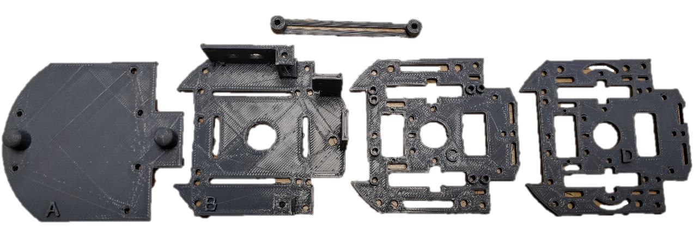

D.

C.

B.

A.

1. 2 electric motors
2. 2 wheels (2 each inner wheel and outer tire)
3. Battery pack
4. 2 male-to-male jumper wires
5. 6 male to female jumper wires
6. Switch
7. 8 hex standoffs (4 short and 4 long)
8. Bolts
   1. 6 – #4-40 x 1”
      1. 4 for motors
      2. 2 for connecting A to B
   2. 4 – #2-56 x ½”
      1. 4 for mounting Arduino and PCB
   3. 8 – #4-40 x ¼”
      1. 8 for connecting standoffs
   4. 11 - #2-56 x ¼”
      1. 3 for line following sensors
      2. 6 for IR sensors
      3. 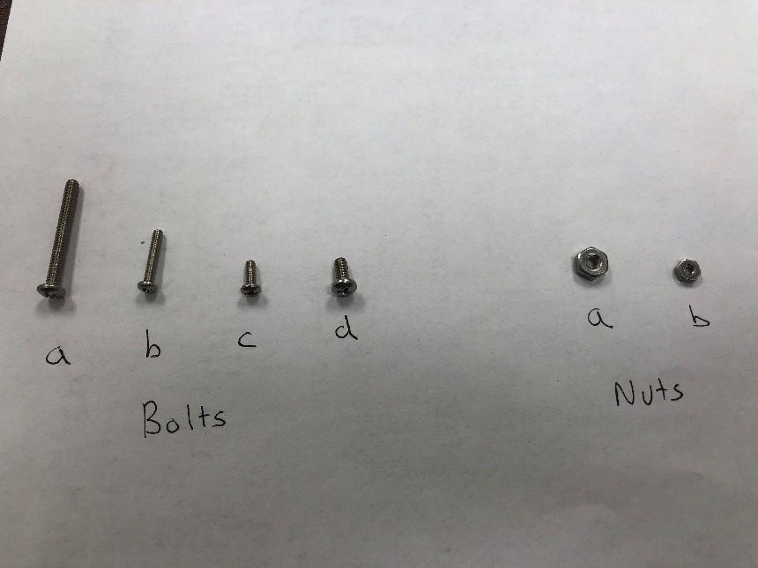2 for wheels
9. Nuts
   1. 6 – #4-40
   2. 13 – #2-56

# PCB Testing

1. Use 4 “c” bolts to attach the 4 short hex standoffs to layer B. Ensure the rods point opposite the printed B, and attach them to the outermost holes in the layer.
2. Install the 2 electric motors to layer B with the leads facing inwards. The motors have yellow plastic nubs that should face the rear of layer B. The white plastic drive shafts should be protruding through the side flanges of layer B. Use 2 “a” bolts and 2 nuts to secure each motor (Ensure the screw heads are to the outside).

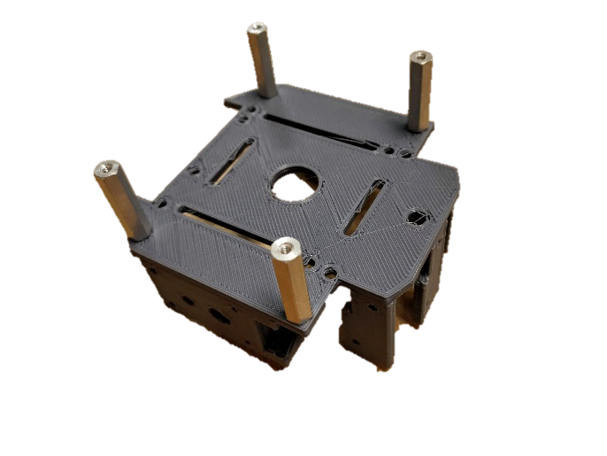 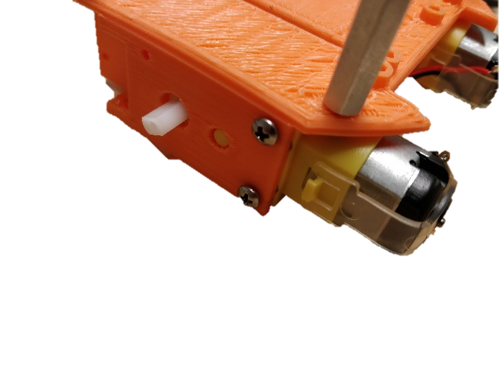

It’s still layer B, it’s just orange now.

2

1

1. Wire the motors, Arduino, and battery as shown in the below schematic.

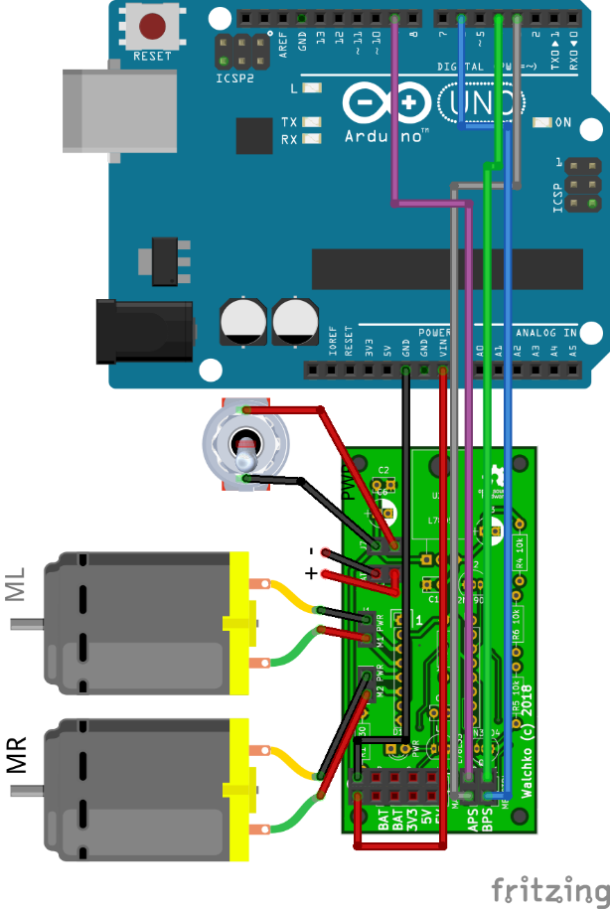

1. Solder the male ends of two male-to-female jumper wires to the connectors protruding from the power switch. Use the nut and lock washer that came attached to the switch to attach it to layer B, facing in the same direction as the hex spacing rods. Wire the female end of the switch to the PCB board as shown above.

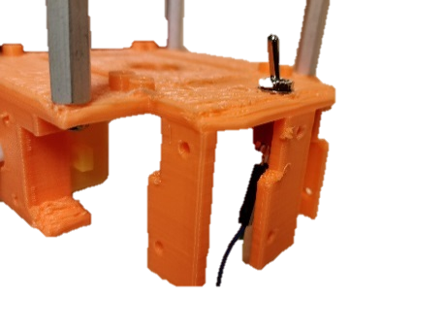

4

1. Attach the wheels by sliding them onto the axles. Use 2 “d” bolts to secure the wheels onto the axles.
2. Download the “PCB_test” folder from the K: Drive Lab 8 folder and upload the *PCB_test.ino* file to your Arduino. If your board is working correctly both tires should go forward for 1 second and then the right wheel should go backwards while the left wheel simultaneously goes forwards (turns right). Disconnect the PCB from the motors, battery, and Arduino.

# Construction

1. Use 2 “b” bolts (with nuts) to attach the PCB to layer A. Note that the PCB should be offset from the plastic layer by the printed spacers. It should be attached to the side opposite the printed A. Orient the red LED towards the back of the bot.

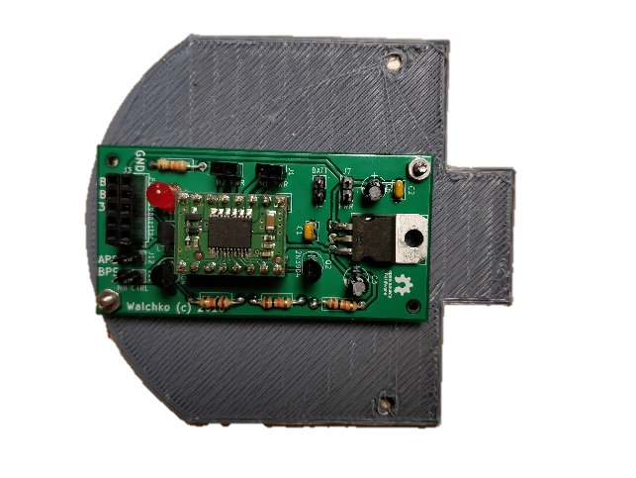

1

1. Using 2 “b” bolts and nuts, attach the Arduino Uno to layer C. The printed spacer nubs should be holding the board off of layer C. It should be on the same side of the layer as the printed C, with the USB-A jack facing towards the front.
2. Use the 4 long hex spacer rods to attach layer C with the Arduino to layer B. The male screw threads protruding from the rods poke through holes in layer C to screw into the tops of the short hex spacer rods.

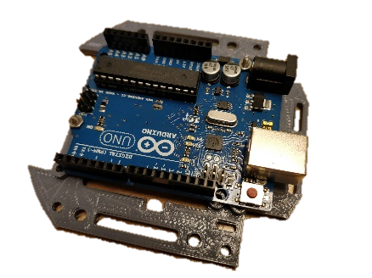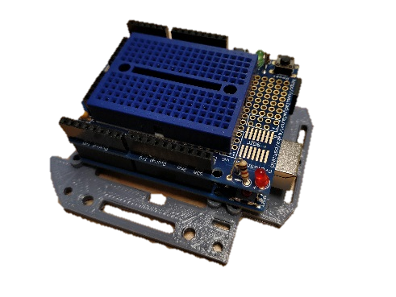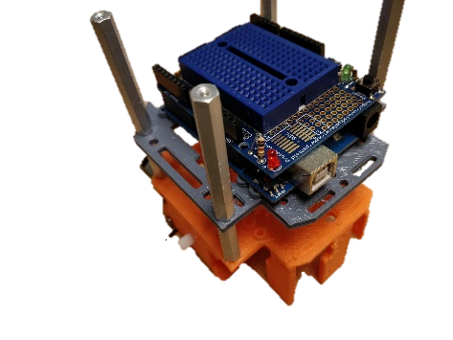

3

2b

2aaaaa

# Wiring

1. Using the diagram below, rewire the Arduino, battery pack, motors, and power switch to the PCB. Do this BEFORE you connect layer A to the rest of the bot.

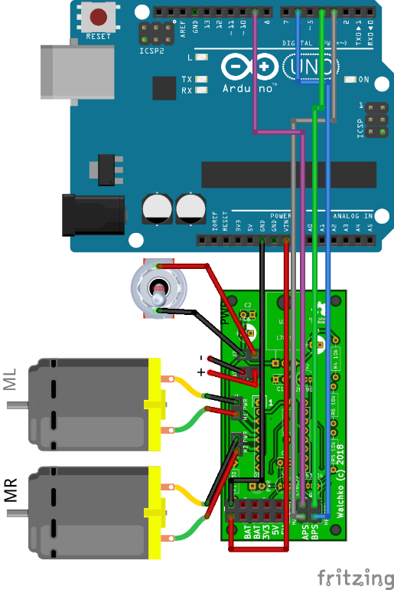

**\*\*\*HINT\*\*\*** Use a male to female jumper to connect the board to the battery and feed through to the top of layer B. This way when you need to change the battery you do not have to disassemble the robot.

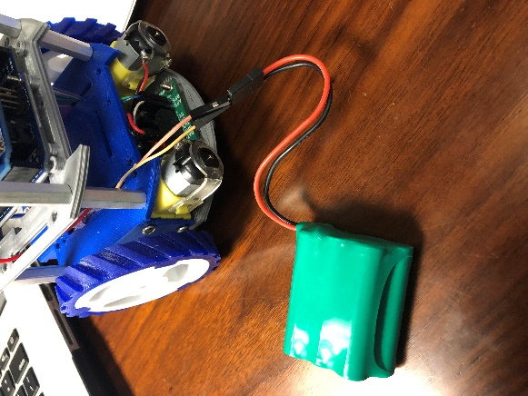

# Finishing up

1. Use a Velcro strap to secure the battery pack to the top of layer B, use a male to female jumper to connect the board to the battery and feed through to the top of layer B. This way when you need to change the battery you do not have to disassemble the robot.
2. Being careful not to damage any of the PCB jumper wire connections, use 2 “a” bolts and nuts to attach layer A to the rest of the bot via the spacer piece.